Trade of Sheet Metalwork
Module 3: | Thermal Processes
Unit 14: | TAG Welding Square Butt Weld – Flat Position
 | Phase 2

Table of Contents
List of Figures 5
List of Tables 5
Document Release History 6
Module 3 – Thermal Processes 7
Unit 14 – TAG Welding Square Butt Weld – Flat Position 7
Learning Outcome: 7
Key Learning Points: 7
Training Resources: 7
Key Learning Points Code: 7
T.A.G./T.I.G. Process 9
Advantages of Gas Shielded (Inert-Gas) 9
Argon Shielding Gas 9
Filler Rods 10
Power Sources 11
A.C. Power Source 11
D.C. Power Source 12
D.C. Suppressor Unit 13
High Frequency Unit 13
Rectifier 13
Argon Gas 13
Electrodes 14
Preparation of Electro Ends 14
Filler Rods 15
Gas Nozzles 15
Transparent Nozzles 16
Direct Current Welding 17
Alternating Current Welding 17
Preparation of Metal for Welding 18
Welding Technique 19
Aluminium Welding 19
Stainless Steel 20
Mild Steel 20
Backing Bars 21
Tack Welding 22
Tack Welding Procedure 22
Striking and Breaking the Arc 23
Fusion without Filler Metal 24
Visual Examination 25
Fusion with Filler Metal 26
Depositing Straight Runs 26
Flat Position 27
Close Square Butt Joint 27
Visual Examination 28
Checklist for T.A.G./T.I.G. 29
Self Assessment 30
Answers to Questions 1-7. Module 3.Unit 14 33
Index 37

List of Figures
Figure 1 - TAGS Welding 8
Figure 2 - Gas Economiser and Flow Meter 10
Figure 3 - Electro Ends 14
Figure 4 - Filler Rods 15
Figure 5 - Gas Nozzles 15
Figure 6 - Transparent Nozzles 16
Figure 7 - Direct Current Welding 17
Figure 8 - Alternating Current Welding 17
Figure 9 - Electrode Extension (A.C.) 19
Figure 10 - Electrode Extension (D.C.) 20
Figure 11 - Backing Bars 1 21
Figure 12 - Backing Bars 2 21
Figure 13 - Striking and Breaking the Arc 23
Figure 14 - Close Square Butt Joint 27

List of Tables
Table 1 - Fusion without Filler Metal 1 24
Table 2 - Fusion without Filler Metal 2 25
Table 3 – Close Square Butt Joint 1 27
Table 4 – Close Square Butt Joint 2 28

Document Release History
Date | Version | Comments
11/10/06 | First draft
08/04/14 | 2.0 | SOLAS transfer

Module 3 – Thermal Processes

Unit 14 – TAG Welding Square Butt Weld – Flat Position
Duration – 4 Hours

Learning Outcome:
By the end of this unit each apprentice will be able to:
- Read and interpret drawing and weld symbol
- Operate and adjust TAGS welding plant
- Tack weld plates to form butt joint
- Complete butt weld in the flat position in 1.2 mm stainless steel

Key Learning Points:
Rk | Weld symbol.  (See “Weld Symbols on Drawings“ section in Module 3 Unit 2)
Rk | DC power source – high frequency unit.
Rk | Shielding gases – types, flow rates.
Sk Rk | Electrodes – types, preparation, stick out length.
Rk Sk | Arc striking – arc length.
Rk Sk | Tacking procedures.
Rk Sk | Welding technique – rod and torch angles.
Rk | Distortion control.
H Rk | Safety precautions – hazards.

Training Resources:

- TAGS welding plant
- 1.2 mm stainless steel
- Videos
- Toolkit
- Safety clothing
- Filler rods
- Figure 1

Key Learning Points Code:
M = Maths D= Drawing RK = Related Knowledge Sc = Science
P = Personal Skills Sk = Skill H = Hazards

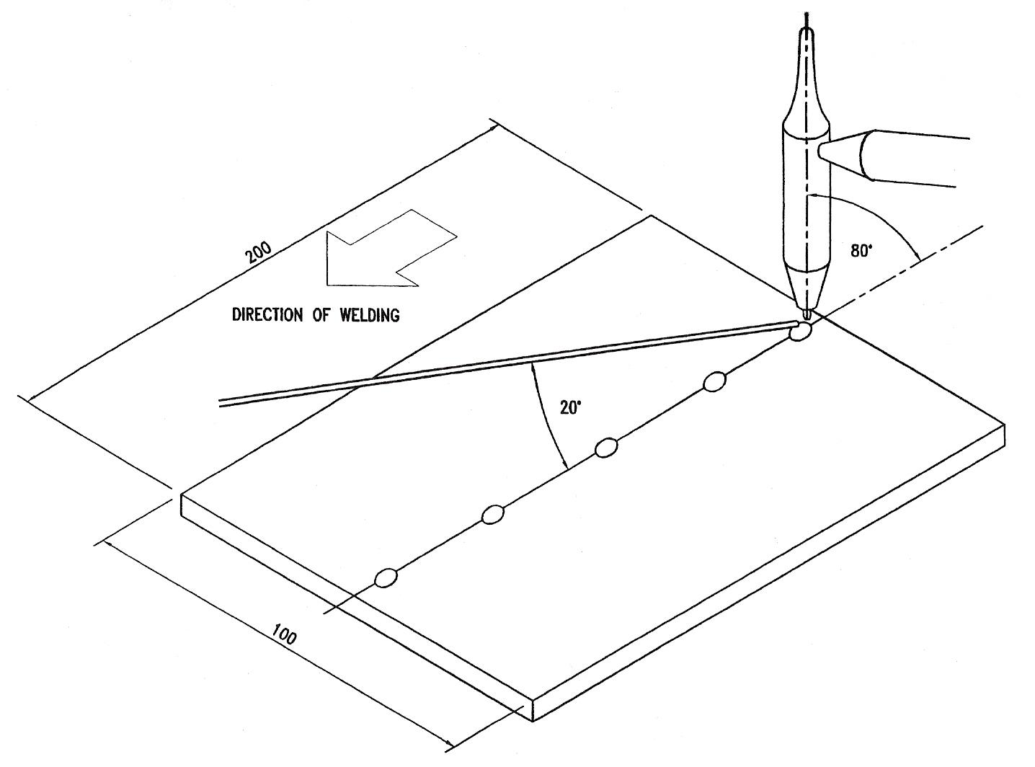
Figure 1 - TAGS Welding

T.A.G./T.I.G. Process
The primary consideration in any welding operation is to produce a weld that has the same properties as the base Metal.
Such a weld can only be made if the molten puddle is completely protected from the atmosphere during the welding process. Otherwise atmospheric oxygen and nitrogen will be absorbed in the molten puddle, and the weld will be weak and porous.
In T.I.G. welding a gas is used as a covering shield around the arc to prevent the atmosphere from contaminating the weld.
The basic manipulation of the T.I.G. process is identical to that used with the oxy-acetylene process with the exception that the welding temperature is supplied by an electrical rather than a chemical source.

T.A.G. welding was originally called T.I.G. meaning tungsten inert gas as inert gases such as argon were used a lot. Nowadays the inert gases have other gases added to them and so are no longer inert gases but active gases and so we have T.A.G. tungsten active gas.

Advantages of Gas Shielded (Inert-Gas)
Since the gas acts as a shield excluding the atmosphere from the molten puddle, the welded joints are stronger, more ductile and more corrosion resistant than welds made by other methods.
The gas simplifies the welding of non-ferrous metals, since no flux is required, whenever a flux is needed, there is always the problem of removing traces of the flux after welding. With the use of flux there is always the possibility of slag inclusion and gas pockets will develop.
Welding can be done in all positions with a minimum of spatter, thus reducing the cost because there is very little time needed in finishing the metal. Another factor is there is very little distortion of the metal near the weld.

Argon Shielding Gas
Welding grade argon is used as the shielding gas in practically all applications.
Argon is supplied in steel cylinders “Light Blue in Colour”. The usual size is 300 ft.³ charged at a pressure 2500 16/in.².

Filler Rods
Filler rods should be clean, dry and free from grease.
Store them carefully, in the packets supplied, in a dry place and do not leave them lying about in the workshop or exposed to the weather.
For important work, the cleaned filler rod should not be touched with the bare hands, as perspiration causes significant contamination.
Wear clean, flexible, soft leather or fire-proofed cotton gloves, as it is essential that one should have precise control of the manipulation of the filler rod.
Equipment, particularly composite power sources, varies considerably in their control arrangements.
Always consult the manufacturer’s instruction book.
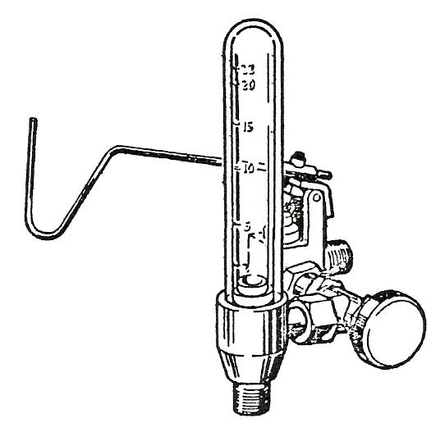
Figure 2 - Gas Economiser and Flow Meter

Caution
Cylinder pressure should never be allowed to fall below 30 lb./in.² since atmospheric contamination may then occur.
Make sure that valves on used cylinders are closed to avoid contamination of the small amount of gas remaining in the cylinders.

The gas flow is measured and controlled by a valve and flow meter.
In simple form it may be of the bobbin-type.
In composite equipment, automatic flow controls, for both gas and water are usually fitted.
Operating in conjunction with the contactor allowing argon to flow for a pre-set time before and after the current flow.

Power Sources
These are classified into two broad groups:
- Alternating Current (AC)
- Direct Current (DC)

The sizes vary considerably, i.e. 3 - 400 amperes output.
AC is used for welding aluminium, magnesium, alloys based on these metals and aluminium bronze.
DC is used for welding mild steel, alloy steels including stainless steel, copper, copper alloys, nickel alloys, titanium and other rare and reactive metals.

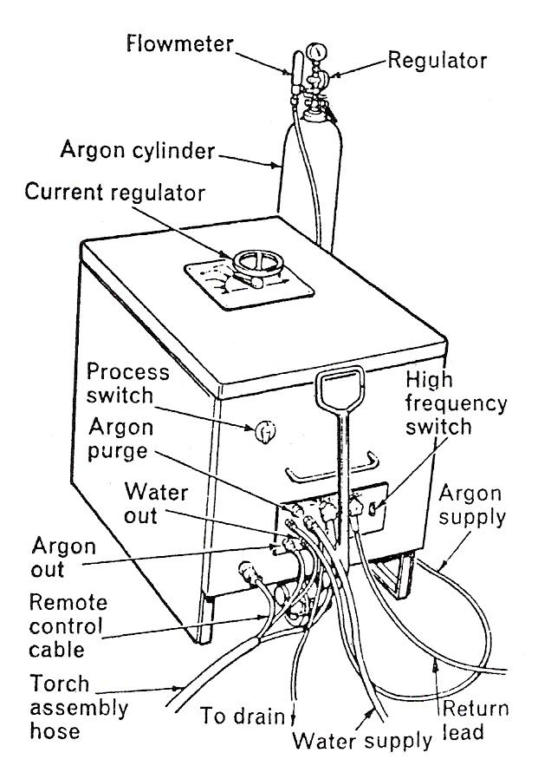
A.C. Power Source
Usually single-phase transformer either air or water colled. The built in auxiliaries usually includes:

- Remote-controlled contractor to enable the operator to switch on off the Welding Current.
- Capacitor to suppress the D.C. component produced in the Welding Circuit.
- A high-frequency unit or a combined h.f. and voltage purge injected to start and maintain the arc.
- Solenoid to control the gas and water supply/flow.

Note:
In many cases a switch is fitted thus enabling the power source to be used for manual arc welding.

D.C. Power Source
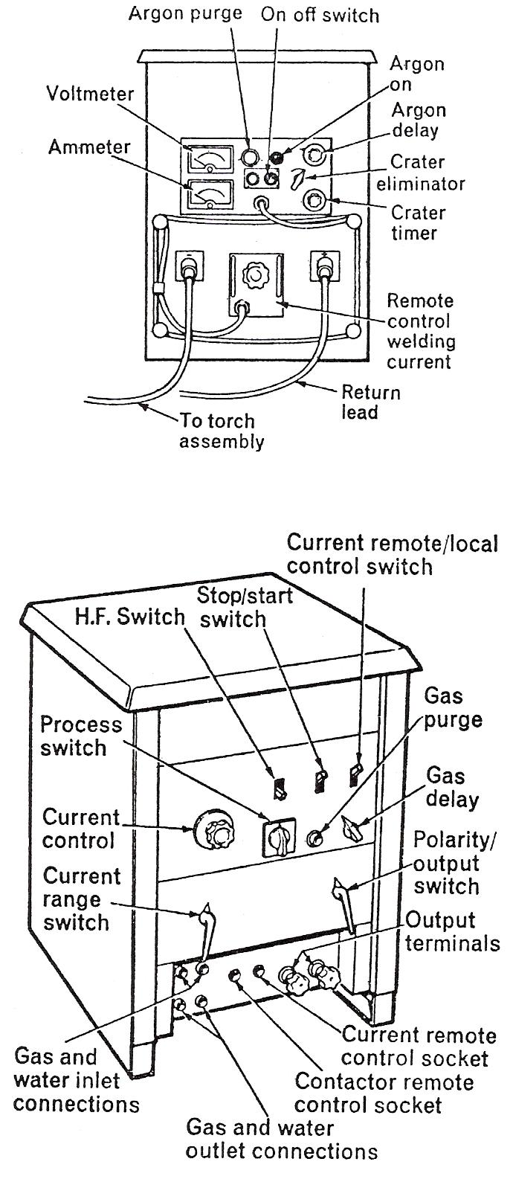
Usually three phase rectifier units comprising of:
- Transformer.
- Rectifier bank.
- Remote controlled contractor.
- Spark starter to initiate the arc.
- Solenoids to control gas and water supplies.
- Sometimes remote control of welding current.

Note:
A switch may be filled thus enabling it to be used as manual arc plant D.C.

A.C./D.C. Composite Equipment.
Single phase transformer Rectifiers can provide either A.C. or D.C. as required. These power sources usually include automatic high frequency sources for both A.C. and D.C. welding together with the usual auxiliaries.

Power Sources used for Manual arc welding can be used for T.I.G. Welding if additional features are added to the circuit. It’s better to use a power source specially designed for T.I.G. Welding and can also be used for Arc Welding.

D.C. Suppressor Unit
Used in A.C. Argon arc welding to eliminate D.C. current. The suppressor consists of a bank of capacitors which act as a barrier to current, but provide an easy path for A.C. current. The result is a perfect A.C. welding current for A.C. Welding. The suppressor is only used when welding aluminium and magneius base alloys and aluminium bronze.

High Frequency Unit
The high frequency unit is an essential item in A.C. Argon arc welding. High frequency currents are injected into the welding circuits. When the welding torch is held near the earthed workpiece or welding bench a train of high frequency sparks is caused to pass between the tungsten electrode and the workpiece. The main welding arc is then brought into action automatically without need for physical contact between electrode and workpiece, thus reducing the tendency of electrode contamination. The high frequency unit is used in conjunction with D.C. welding for arc striking only, and need not be used continuously during welding.

Rectifier
When D.C. current is required a rectifier is used after the transformer to alter A.C. to D.C. current. Sometimes a rectifier set combines a transformer and rectifier as a combined unit.

Argon Gas
Argon Gas is supplied in 200 cu. ft. capacity steel cylinders at a nominal pressure of 2,000 p.s.i. Cylinders are painted blue, fittings are R.H. threads.
Argon is chemically inert and does not form compounds with other elements; thus it is non-toxic. The high pressure in the cylinders is reduced for welding to 30 p.s.i. by a pressure reducing regulator and the flow of gas is controlled by a flow-meter.
There are many new gases on the market nowadays, e.g. argon with a small fraction of helium which turns the inert gas to an active gas, hence the terms T.I.G. and T.A.G.
Argon, Argonox, Helishield and Argoshield are some of the gases in use.
For aluminium:
Argon = for general purpose, shielding gas.
Helishield = for automated and robotic applications.

Electrodes
Plain tungsten electrodes can be used but those containing a percentage of Thorium or Zirconium give better arc striking and stability. Thoriated tungsten electrodes should be used for D.C. Welding. Zirconiated tungsten electrodes should be used for A.C. Welding. They are particularly suitable for welding aluminium, magnesium, and alloys containing substantial amounts of either of these elements.

Tungsten tips which contain thorium are suspected of causing damage to health. There is a move away from that type on account of that fact. Ceriated tips have replaced thorium.

Preparation of Electro Ends
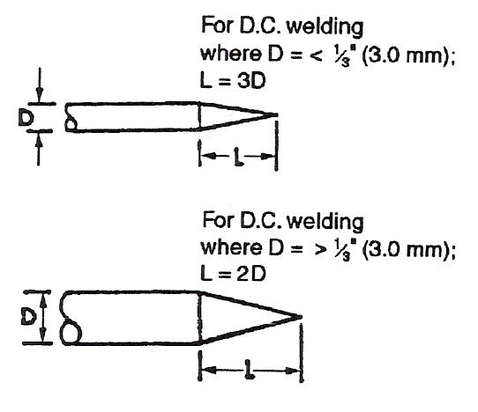
Figure 3 - Electro Ends

The working tip should be ground to provide a point. A silicon carbide wheel grade 0-M60 should be used for this purpose. For D.C. welding a sharp point is desirable. The taper length of Electrodes up to 1/8˝ (3.0 mm) should be approx. three times the diameter and for electrodes of 1/8˝ (3.0 mm) it should be approx. twice the diameter.

For A.C. welding a "ballad" point is desirable with the end pre-shaped to an angle of 45° approx., leaving a blunt point of half the diameter approx. Before use an arc should be struck on similar metal to ball the point of the electrode.

Filler Rods
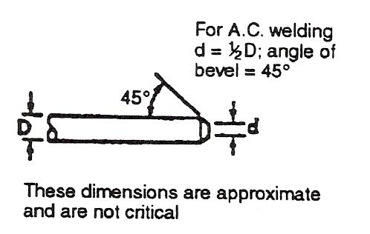
Figure 4 - Filler Rods

They should be kept clean, dry and free from grease, store them carefully in the packets, supplied in a dry place and do not leave them lying around in the workshop or exposed to the weather for important work the clean rods should not be touched by bare hands. Wear gloves.

Gas Nozzles
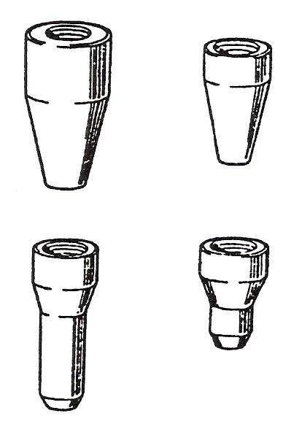
Figure 5 - Gas Nozzles

The standard ceramic nozzles are ¼˝ (6.0 mm) bore for GIR cooled torches and 3/8˝ (10.0 mm) for water-cooled torches.
Larger sizes or/and special types are available for special applications.

Transparent Nozzles
Transparent nozzles may be used to obtain a better view of the arc.
Gas nozzles, by their nature, are not strong, and the ageing effect of repeated heating and cooling may make them fragile.
Take care not to drop the torch, nor to bring the nozzle into sharp contact with other objects.
A ‘gas lens’ may be fitted to some torches within the shield to improve the gas coverage and allow welding to take place with greater extensions of the electrode beyond the shield.

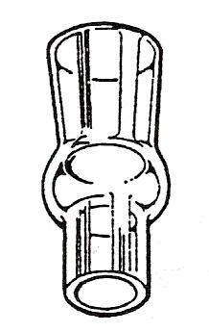
Figure 6 - Transparent Nozzles

Direct Current Welding
When using D.C. approx. two thirds of the heat energy is created at the positive end of the arc. To prevent overheating and possible melting of the electrode correct it to the negative terminal of the power source.
When using D.C. the heat generated is split into one third to the negative pole and two thirds to the positive pole. By attaching the electrode to the negative pole we allow the weld pool to get 2/3 of the heat while keeping the electrode relatively cool at 1/3 of heat.

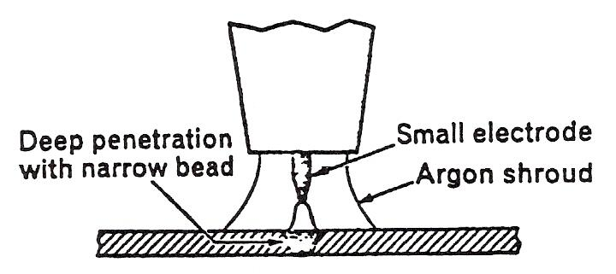
Figure 7 - Direct Current Welding

Alternating Current Welding
When using A.C. a larger diameter, electrode is required for the same welding current and the depth of penetration will be less than with D.C. electrode.
In A.C. welding the heat is split evenly between the two poles. On account of this there is no advantage in switching polarity, i.e. making the electrode positive rather than negative.

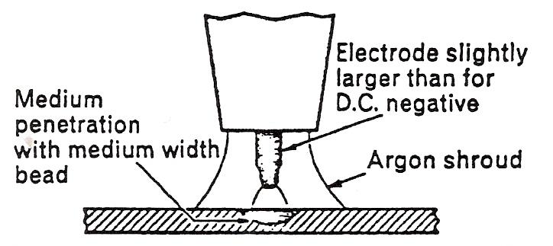
Figure 8 - Alternating Current Welding

Preparation of Metal for Welding
Make sure that the metal is clean, free from dirt or grease more especially at fusion faces. It can be cleaned in a number of ways (i.e. degreasing treatment, wire brush steel wool etc.).

Stainless Steel: When cleaning stainless steel and similar alloys a stainless steel wire brush of stainless steel wool should be used.

Aluminium: The surface oxide of aluminium and its alloys should be removed by wire brushing or steel wool immediately before welding.

Note:
Special care is necessary when degreasing is done with Carbon Tetrachloride or Teichlocothylene or Perchlorethylene. When these substances are brought in contact with the arc their vapours decompose to form a toxic gas. Degreasing must be done away from the welding area, and all traces of the substance must be removed before welding.

Welding Technique
For the welding of all materials the “Leftwards” welding technique is used to ensure an effective gas shroud. With the torch in right hand welding is carried from right-left and with the torch in left hand welding is carried out from left-right.

Aluminium Welding
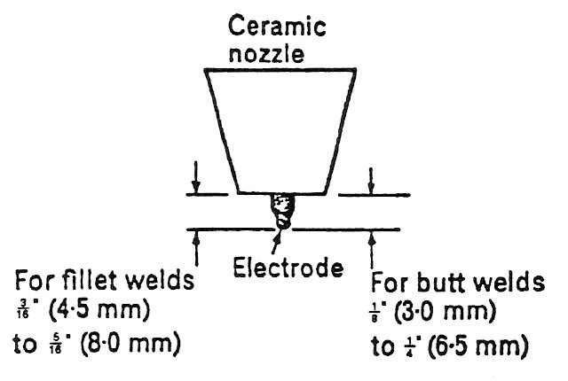
Figure 9 - Electrode Extension (A.C.)

- Use commercially pure aluminium 99.5% parent metal.
- Filler Rod specified B.S. 2901 G.I.B.
- A.C. welding equipment.
- Zirconiated tungsten electrode.
- 3/8˝ (10.0 mm) bore gas nozzle up 1/16˝ (1.5 mm) and 1/8˝ (12.01 mm) for thicker sheets.
- Electrode extension as shown.
- Arc length same as diameter of electrode. Max of 1/4˝ (6 mm).

Stainless Steel
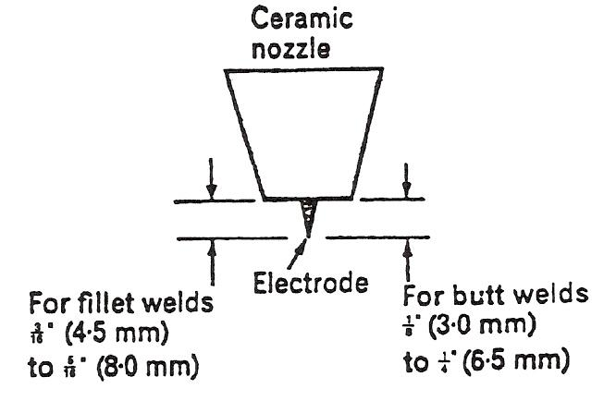
Figure 10 - Electrode Extension (D.C.)

- Use 18/8/1 stabilised corrosion-resistant steel.
- Use filler rod complying with B.S. 2901, A8N6.
- D.C. welding equipment.
- Thoriated tungsten electrode.
- Use 3/8˝ (10 mm) gas nozzle.
- Electrode extension as shown (unless otherwise stated).
- Arc length 1/16˝ (1.5 mm) when not using filler rod and when using rod.

Mild Steel
Mild steel may be used instead of stainless steel for training purposes. Carbon content should be less than 0.12% of sulphur less 0.04%.

- Use filler rod complying with B.S. 1453 A3.
- Increase Argon flow to 12 ft.³/hr.
- Increase amperes by 15 over that recommended for stainless steel.

Backing Bars
It will be found helpful to use a recessed backing support when welding butt joints. This will control the penetration bead and enable higher current to be used.
The backing bars should be made of copper when welding ferrous materials, and preferable of stainless steel for non-ferrous metals. It should be provided with a longitudinal groove of suitable dimensions, i.e. depth of one third (1/3) the thickness of metal being welded and having radius of 1/4˝ (6·0 mm).
For many metals, including stainless steel, but not aluminium it is desirable to have an Argon backing. Small vertical holes, communicating with a longitudinal supply hole at 25 mm spacings along the groove to provide a supply of Argon to the underside of the joint.
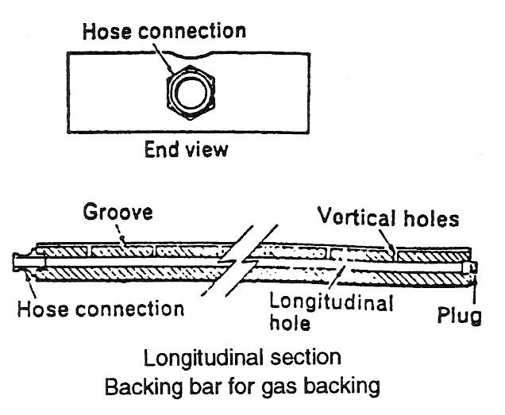
Figure 11 - Backing Bars 1

Take care that the joint assembly does not lift away from the backing bar during welding or burn through may occur. Lack of such care makes the welding more difficult.
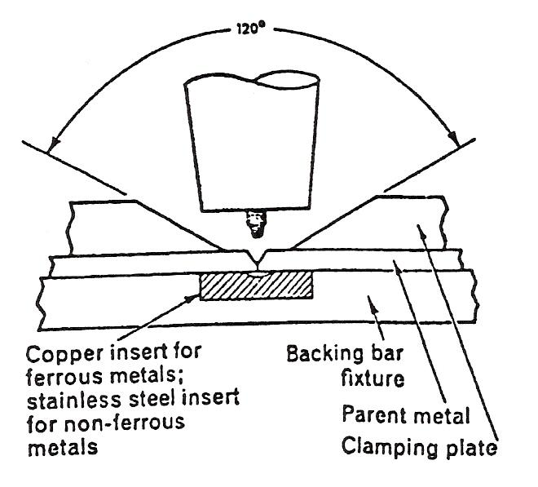
Figure 12 - Backing Bars 2

Tack Welding
The possibility of loss of Argon shrouding when tack welding the ends of joints must be allowed for. Supporting the joint with a backing bar extended beyond the end of the joint will help to prevent this loss. The flow rate of Argon should be increased by about 2 ft.³/hr and the electrode extension restricted to 3/16˝ (4.5 mm). End tacks should be of a length equal to four times the thickness of the metal being welded.

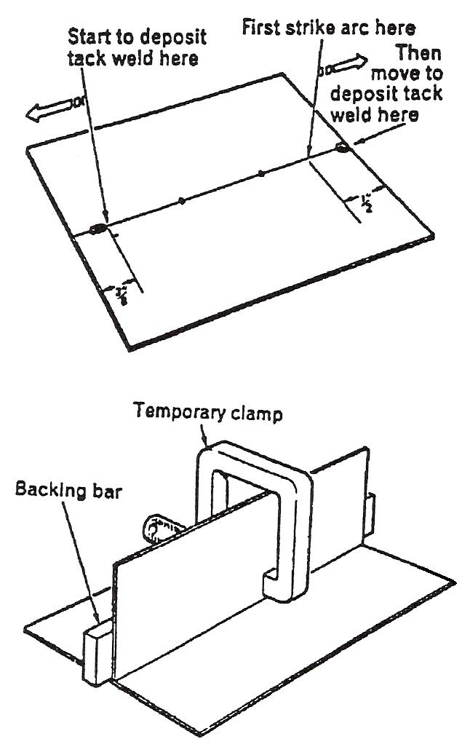
Tack Welding Procedure
- Set the appropriate conditions for welding but with increased Argon flow.
- Strike an arc 12 mm (1/2") from the right-hand end of the joint.
- Quickly move the torch back so that the electrode is pointing at the end of the joint at an angle of 65° - 70°.
- As soon as fusion is established melt sufficient fitter rod to make a tack of the length required.
- Make sure the sheets are tightly abutted together of 10.0 mm (8") from other end repeat the procedure.
- Make intermediate spot tacks by depositing a small bead of weld with fitter metal at the appropriate spot.

Striking and Breaking the Arc
When using composite power sources, the argon purge and the argon delay times should be set to give argon flow for 10-15 seconds. If a crater eliminator is included, the control should be set to the recommended time, usually between 1 and 3 seconds. With this unit, the welding current is automatically and gradually reduced to the minimum rating of the power source instead of stopping abruptly when the torch or foot switch is depressed to stop welding.
If the foot switch provides remote control of the welding current value, it can be used as a non-automatic crater eliminator by gradually reducing the current value within the limits set by the controls in the power source.

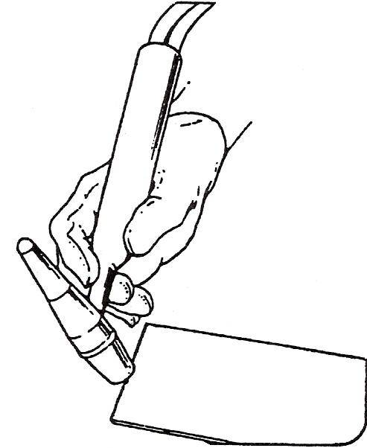
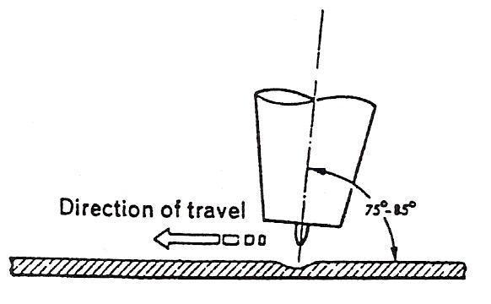
Figure 13 - Striking and Breaking the Arc

Fusion without Filler Metal
MATERIAL | 16 s.w.g. (1.5 mm)  stainless steel,  1 off, min. 4·(10.0 cm)  x 6" (15.0 cm)
PREPARATION | Clean surface
ASSEMBLY | Support sheet in flat position, with air space below, long axis to be parallel to bench front
ELECTRODE | 1/16˝ (1.5 mm)
ARGON | 4 - 8 ft.³/hr.
CURRENT | 50 - 70 amperes
Table 1 - Fusion without Filler Metal 1

- Hold torch between the forefinger and thumb of the right hand with the torch handle lying on top of the hand and with the hose assembly supported by the forearm.
- With the torch body inclined backwards, so that the electrode is pointing at an angle of 75 - 85°, lower the torch until the electrode end is about 1" (25.0 mm) away from the sheet surface at the right-hand end.
- With welding current switched on, allow argon to flow to purge the hose assembly of air and switch on the high-frequency starter.
- With welding screen in position, lower the torch until the electrode end is in close proximity to the sheet.
- A train of sparks will pass from the electrode. An arc will be established and the high-frequency starter will cease to operate.
- Lower the torch until a short arc length of about 1/16" (1.5 mm) is obtained.
- As soon as a small pool of molten metal is formed where the arc is established, gently. In the torch in a leftwards direction.
- Synchronise the rate of travel with the progressive formation of the molten metal pool.
- The molten pool should be perfectly clean and tranquil without trace of scum or oxide.
- Observe the width of the fused and re-solidified metal. This will be uniform if the speed of leftwards travel is maintained correctly.
- As the torch approaches the left-hand edge of the sheet, switch off the welding current.
- Keep the torch in position over the crater with the argon flowing for 10-15 seconds. This allows weld and tungsten electrode to cool in the protective argon shroud.
Repeat the procedure until the techniques of establishing, maintaining, and breaking the arc are mastered.

Visual Examination
The underside of the sheet should show that there has been near penetration of the sheet. If a burn through has occurred it will be the result of excessive concentration of heat, either by the use of too high a welding current or too slow a rate of travel.

MATERIAL | 16 s.w.g. (1.5 mm)  stainless steel,  1 off, min. 4˝ (10.0 cm)  x 6˝ (15.0 cm)
PREPARATION | Clean surface
ASSEMBLY | Support sheet in flat position, long axis parallel to bench· front
ELECTRODE | 1/16˝ (1.5 mm)
ARGON | 5-8 ft.³/hr.
CURRENT | 50-70 amperes
FILLER | 1/16˝ (1.5 mm)
Table 2 - Fusion without Filler Metal 2
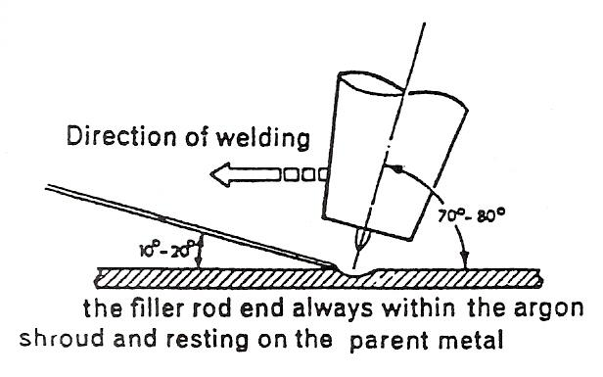

If the fused metal is not bright and clean after gentle wire brushing, or if the electrode end is discoloured, the argon flow should be checked for possible blockage or leakage or false flow meter reading. Too long an arc length may be another possible cause.

Fusion with Filler Metal
When using the leftwards method and a filler rod, the arc is directed towards the unwelded portion of the joint, and the filler rod is directed towards the welded portion of the joint.
Sometimes in the handling of the filler rod, the tungsten electrode may become contaminated by accidental contact with the filler rod end. If so, the arc should be broken immediately, the electrode removed and replaced or ground to remove the contamination and the end re-prepared.

Depositing Straight Runs
Example Procedure EP43

- Establish small pool of molten metal near right-hand edge of sheet, holding torch vertical.
- Decrease the electrode angle to 70°-80°.
- Hold filler rod in left hand, between the fingers and thumb, pointing at the front edge of the molten pool and at an angle of 10°-20°.
- Allow the arc heat to melt a little metal from the end of the filler rod and start the leftwards movement of the torch.
- Always keep the filler rod end within the argon shroud, making contact with the weld pool but not with the electrode when adding filler metal.
- Steady addition of filler metal gives even deposition. The rate of travel leftwards should be co-ordinated with melting of filler rod to control size of bead and extent of penetration.
- Repeat the procedure until separate straight runs of even shape and width can be produced at will with a consistent arc length of less than 1/8˝ (3.0 mm). Do not allow parent metal to become over-heated.

Flat Position

Close Square Butt Joint
Example Procedure EP49
- Establish the arc at the right-hand end of the joint with the electrode held at an angle of 70° - 80°.
- Immediately fusion to the root of the joint is obtained add filler metal to prevent excessive fusion of parent metal.
- Commence leftwards movement without weaving of torch.
- Co-ordinate addition of filler metal, and rate of travel so as to maintain fusion to the root and build up the weld to a slightly convex profile.
- Add filler metal immediately if excessive penetration seems imminent.

MATERIAL | 16 s.w.g. (1.5 mm)  aluminium,  2 off, min. 4˝ (10.0 cm)  x 6˝ (15.0 cm)
PREPARATION | Square edge
ASSEMBLY | Tack weld with five tacks, no gap. Support in flat position with air space below.
ELECTRODE | 3/32˝ (2.5 mm)
ARGON | 12-15 ft.³/hr.
CURRENT | 70-85 amperes
FILLER | 3/32˝ (2.5 mm)
Table 3 – Close Square Butt Joint 1
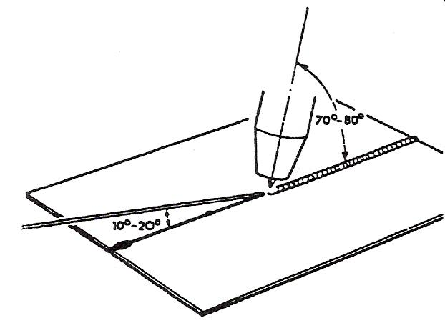
Figure 14 - Close Square Butt Joint
Example Procedure EP50
- As for EP49 except for the amended welding conditions.

MATERIAL | 16 s.w.g. (1.5 mm)  aluminium,  2 off, min. 4˝ (10.0 cm)  x 6˝ (15.0 cm)
PREPARATION | Square edge
ASSEMBLY | Tack weld with five tacks, no gap. Support in flat position with air space below.
ELECTRODE | 3/32˝ (2.5 mm)
ARGON | 12-15 ft.³/hr.
CURRENT | 70-85 amperes
FILLER | 3/32˝ (2.5 mm)
Table 4 – Close Square Butt Joint 2

Visual Examination
Satisfactory welds for EP49 and EP50 will have the deposited metal built up to a consistent height, just proud of the parent metal surface.

The weld run should be about 1/8˝ (3.5 mm) wide and uniform width along the length of the joint.

The underside of the joint should indicate that consistent fusion to the root of the joint has been obtained by the presence of a uniform but small penetration bead.

Checklist for T.A.G./T.I.G.
Always check the following:
- Comply with the safety precautions and fire-prevention procedure.
- That the return lead is firmly connected to the bench and power source.
- That all connections to the torch hose assembly are in good order.
- That the argon and water hoses are not 'kinked' or obstructed.
- Power is switched on.
- Argon cylinder valve is open.
- The regulator, if not pre-set type, is set to 3016/in pressure.
- The correct size gas nozzle is fitted to the torch.
- The tungsten electrode is of the correct type and size, is clean, and correctly prepared.
- The electrod extension is correct for the work to be done.
- The argon flow is set correctly.
- The gas delay and gas purge are correctly set.
- The power supply to separate high-frequency unit is switched on.
- The separate foot switch is connected.
- The water supply is turned on and the flow train is correct (when using water cooled torch).
- That the crater eliminator controls are correctly set on a composite power source.
- Use protective equipment and clothing.
- Acquire a relaxed/comfortable position for welding.
- Acquire correct holding position for torch that will allow run to be completed with acquiring new position.
- Warn any person in the vicinity when about to strike an arc.
- Ensure that any portable screens are in position.
- Keep the welding shield on until arc is broken.
- Close down plant at end of welding:
  - Switch off plant;
  - Close cylinder valve;
  - Turn off water supply;
  - Switch off power supply to power source and to separate high-frequency unit;
  - Place torch in safe place;
  - Collect unused filler rods and store carefully.

Self Assessment
Questions on Background Notes – Module 3.Unit 14

1. Give two advantages of gas shielding.

2. List two metals you may T.A.G weld and state if A.C. or D.C. should be used.

- What type of point is used for D.C. and A.C.?

4. To obtain deep penetration with a narrow bead which current should you use?

5. What measurement should the electrode be for butt welds and fillet welds using
A.C.?

6. What distance should the arc length be for A.C./D.C.?

7. What length should a tack weld be?

Answers to Questions 1-7. Module 3.Unit 14
1.

Gas Shielding:

The welding joints are stronger, more ductile and corrosion
resistance.

There is no flux residue to cause problems.

Welding can be done in all positions and also there is very
little distortion.

2.

T.A.G welding with A.C.

Aluminium, magnesium and alloys based on these metals.

T.A.G welding with D.C.

Mild steel and mild steel alloys, stainless steel, copper, copper
Alloys, nickel alloys, titanium and other reactive / rare metals.

3.

The electrode point or tip should be sharp for D.C. the taper
length of electrodes up to 3.0mm should be approximately three
times the diameter and for electrodes of 3.0mm it should be
approximately twice the diameter.

L = 3D where D = < 3.00mm

L = 2D where D = > 3.00mm

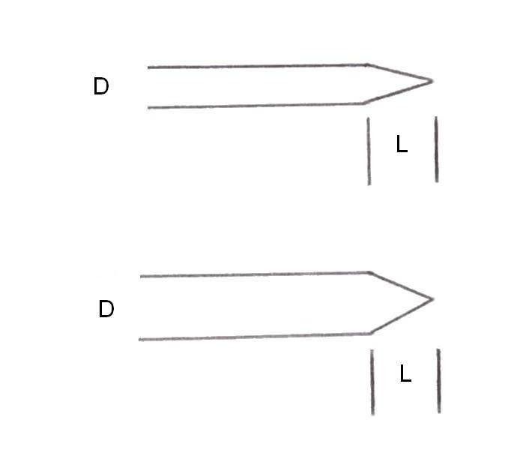

For A.C welding a ballad point is needed, with the end pre-shaped
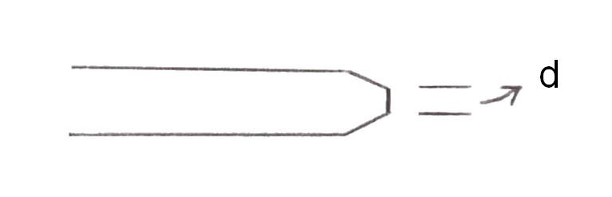
to an angle of 45º

d = ½ D

4.

D.C gives deep penetration as the current is split:

⅔ Positive ⅓ Negative

5.

The electrode should be 4.5mm to 8.0mm for filler welds
and 3.00mm to 6.5mm for butt welds.

6.

Arc length for A.C.

The arc length for A.C. is the same as the diameter of electrode
up to a maximum of 6.mm.

Arc length for D.C.

When using D.C its 1/16 inch or 1.5mm.

7.

Four times the thickness of metal being welded.

Index

A
Alternating Current Welding, 17
Argon Gas, 13
C
Checklist for T.A.G./T.I.G., 29
Close Square Butt Joint
Visual Examination, 28
D
D.C. Suppressor Unit, 13
Direct Current Welding, 17
E
Electrodes, 14
Filler Rods, 15
Gas Nozzles, 15
Preparation of Electro Ends, 14
F
Flat Position, 27
Close Square Butt Joint, 27
Fusion without Filler Metal
Visual Examination, 25
H
High Frequency Unit, 13
P
Preparation of Metal for Welding, 18
R
Rectifier, 13
S
Self Assessment, 30
Striking and Breaking the Arc, 23
Depositing Straight Runs, 26
Fusion with Filler Metal, 26
Fusion without Filler Metal, 24
T
T.A.G./T.I.G. Process, 9
A.C. Power Source, 11
Advantages of Gas Shielded (Inert-Gas), 9
Argon Shielding Gas, 9
D.C. Power Source, 12
Filler Rods, 10
Power Sources, 11
Transport Nozzles, 16
W
Welding Technique, 19
Aluminium Welding, 19
Backing Bars, 21
Mild Steel, 20
Stainless Steel, 20
Tack Welding, 22
Tack Welding Procedure, 22

